DCC-GARCH correlation: EURUSD and USDCHF
Method 09 / GARCH(1,1) + Engle DCC / Alpari D1 full available history

Study setup
Logical pair: EURUSD , USDCHF
Broker symbols: EURUSD_i , USDCHF_i
Snapshot: 2026-11-03_majors_alpari_D1
Timeframe: D1
Matched return window: 1999-01-05 to 2026-11-02 (UTC bar dates)
Matched return count n: 7186
Dropped unfinished last bar dated 2026-11-03 UTC after a tick-volume check against the prior complete day.
EURUSD GARCH(1,1): mu=0.000011, omega=0.001149, alpha=0.036723, beta=0.960004
USDCHF GARCH(1,1): mu=-0.000339, omega=0.003450, alpha=0.040980, beta=0.956768
DCC: a=0.136115, b=0.500000, a+b=0.636115
Burn-in ignored in path summaries and chart: first 60 updates
Complete matched rows (Excel): EURUSD-USDCHF_DCC_D1.xlsx
Complete matched rows (HTML table): EURUSD-USDCHF_DCC_D1_data.html

Method carried forward
DCC-GARCH first fits a constant-mean GARCH(1,1) on each matched daily log return of close, ln(close_t / close_t-1), then updates Engle (2002) dynamic conditional correlation on the standardised shocks z = residual / conditional sigma. Quotes are not inverted. Correlation targeting sets Q_bar to the sample correlation of z; a and b are estimated by maximising the bivariate Gaussian DCC likelihood with a >= 0, b >= 0, and a + b < 1. Path summaries ignore the first 60 updates. The headline is rho on the last day. Same-sample Pearson r on log returns is a side check only. A high |rho| does not prove cause, lead-lag, or a trading signal.

Results
Latest DCC rho: -0.752457
Post-burn-in path (n=7126): mean=-0.760469, median=-0.767087, min=-0.945286, max=0.721349, std=0.072830
Share of post-burn-in days with |rho| >= 0.4: 99.61%; |rho| >= 0.7: 89.45%
Same-sample Pearson r: -0.749204
Latest rho minus r: -0.003254

Conclusion
Over 7186 matched daily log-return rows for EURUSD and USDCHF (broker quote directions unchanged), latest DCC rho is -0.7525 (negative, strong conditional linear link in this sample) with fitted a=0.1361, b=0.5000 (a+b=0.6361). After a 60-day burn-in, path mean is -0.7605 and std is 0.0728. Same-sample Pearson r is -0.7492 (latest rho minus r = -0.0033). This does not establish cause, lead-lag, or a lasting trading rule.

Charts
Daily closes

Daily log returns
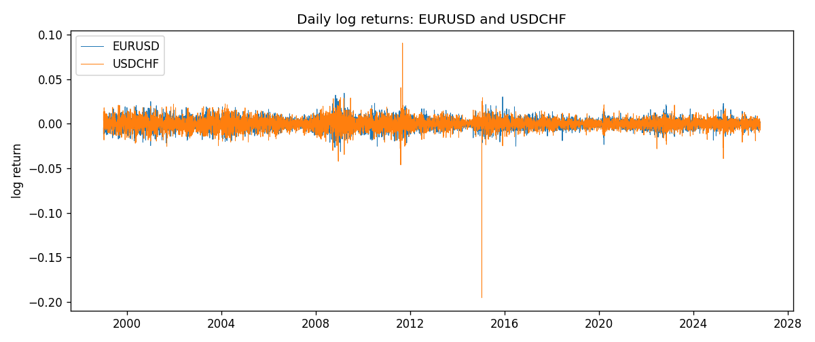
DCC rho path with Pearson r reference
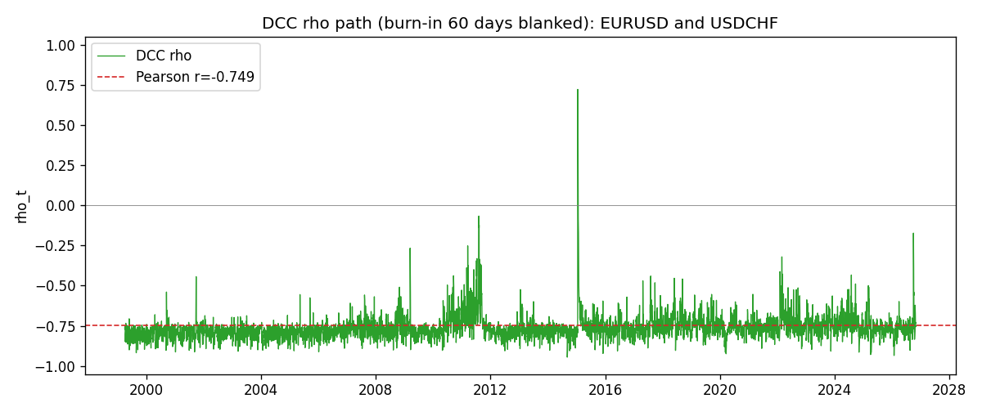

Data report
Every matched row that entered the DCC recursion is stored in the sibling Excel workbook named EURUSD-USDCHF_DCC_D1.xlsx. Embedding all rows as a Word table is impractical at this length; the Word file holds the column list, column summaries, and the first and last 15 matched rows.
Columns: time, EURUSD_open, USDCHF_open, EURUSD_high, USDCHF_high, EURUSD_low, USDCHF_low, EURUSD_close, USDCHF_close, EURUSD_tick_volume, USDCHF_tick_volume, EURUSD_spread, USDCHF_spread, EURUSD_real_volume, USDCHF_real_volume, EURUSD_log_return, USDCHF_log_return, EURUSD_sigma, USDCHF_sigma, EURUSD_z, USDCHF_z, q11, q22, q12, rho_t
Column summaries (matched calculation rows)
column | count | mean | std | min | 25% | 50% | 75% | max
EURUSD_open | 7186 | 1.181536 | 0.15083018 | 0.8272 | 1.086205 | 1.16621 | 1.29401 | 1.5995
USDCHF_open | 7186 | 1.0974503 | 0.25221737 | 0.72022 | 0.9205325 | 0.9899 | 1.23765 | 1.8219
EURUSD_high | 7186 | 1.1866696 | 0.15143104 | 0.8326 | 1.090285 | 1.17131 | 1.299445 | 1.6038
USDCHF_high | 7186 | 1.102742 | 0.25396197 | 0.73305 | 0.924775 | 0.99353 | 1.2422 | 1.8313
EURUSD_low | 7186 | 1.1765242 | 0.15015364 | 0.8227 | 1.0820725 | 1.16258 | 1.2885325 | 1.5865
USDCHF_low | 7186 | 1.0923313 | 0.25063382 | 0.08565 | 0.91721 | 0.98623 | 1.2315 | 1.8121
EURUSD_close | 7186 | 1.1815785 | 0.15080545 | 0.8267 | 1.0860875 | 1.166185 | 1.2941 | 1.5997
USDCHF_close | 7186 | 1.0974447 | 0.25212504 | 0.72025 | 0.920795 | 0.98995 | 1.237525 | 1.8217
EURUSD_tick_volume | 7186 | 103207.57 | 173534.06 | 218 | 9426 | 52774.5 | 99579.75 | 1471626
USDCHF_tick_volume | 7186 | 74325.102 | 113489.5 | 18 | 12800 | 40232.5 | 70435.25 | 858589
EURUSD_spread | 7186 | 19.339549 | 16.550572 | 0 | 8 | 12 | 20 | 50
USDCHF_spread | 7186 | 26.036877 | 24.695014 | 0 | 5 | 16 | 50 | 100
EURUSD_real_volume | 7186 | 4.0330482e+10 | 1.6691688e+11 | 0 | 0 | 0 | 0 | 3.6149665e+12
USDCHF_real_volume | 7186 | 2.3290849e+10 | 8.9127816e+10 | 0 | 0 | 0 | 0 | 1.9331921e+12
EURUSD_log_return | 7186 | -3.06e-06 | 0.00580427 | -0.03123819 | -0.00324267 | 0 | 0.00325778 | 0.03433183
USDCHF_log_return | 7186 | -6.921e-05 | 0.00659379 | -0.19545699 | -0.00335085 | 8.077e-05 | 0.003323 | 0.09051364
EURUSD_sigma | 7186 | 0.0055697 | 0.00170126 | 0.0025795 | 0.00432455 | 0.00538711 | 0.0065012 | 0.01459161
USDCHF_sigma | 7186 | 0.00655102 | 0.00254802 | 0.00361664 | 0.00508343 | 0.00610332 | 0.00732583 | 0.0398893
EURUSD_z | 7186 | -0.00289811 | 1.0000319 | -5.7823167 | -0.6188072 | -0.00183838 | 0.60941324 | 5.2049235
USDCHF_z | 7186 | 0.03916316 | 0.99910676 | -34.477475 | -0.48080465 | 0.06971338 | 0.59696713 | 6.7452553
q11 | 7186 | 1.0000293 | 0.26728213 | 0.73610621 | 0.83811556 | 0.92294514 | 1.069022 | 5.3140767
q22 | 7186 | 0.99987996 | 2.2144765 | 0.72883551 | 0.81468445 | 0.88630781 | 1.0119398 | 162.57846
q12 | 7186 | -0.7434098 | 0.28714151 | -3.8333073 | -0.80851049 | -0.68487851 | -0.61390489 | 12.443745
rho_t | 7186 | -0.76065618 | 0.07260452 | -0.94528557 | -0.79549331 | -0.76719074 | -0.74104008 | 0.72134945
First 15 matched rows (selected columns)
time | EURUSD_log_return | USDCHF_log_return | EURUSD_sigma | USDCHF_sigma | EURUSD_z | USDCHF_z | q11 | q22 | q12 | rho_t
1999-01-05 | -0.0048360507 | 0.0039424743 | 0.0065891553 | 0.0083861765 | -0.7356386 | 0.51050434 | 1 | 1 | -0.74356974 | -0.74356974
1999-01-06 | -0.011547966 | 0.013605652 | 0.0065313268 | 0.0082694434 | -1.7698016 | 1.686251 | 0.93754563 | 0.89935868 | -0.69347635 | -0.75521217
1999-01-07 | 0.0076280636 | -0.0093883841 | 0.0067803885 | 0.0085872465 | 1.1233689 | -1.0538511 | 1.2589966 | 1.2005992 | -1.0235237 | -0.83250455
1999-01-08 | -0.010902799 | 0.011040268 | 0.0068103141 | 0.0086170785 | -1.6025672 | 1.3205141 | 1.1651546 | 1.1153542 | -0.94347725 | -0.82762434
1999-01-11 | -0.007103287 | 0.0052963193 | 0.0070010361 | 0.0087575748 | -1.0162029 | 0.64344578 | 1.2960355 | 1.1589135 | -1.0303605 | -0.8407275
1999-01-12 | 0.0045103728 | -0.0098275602 | 0.007001986 | 0.0086617407 | 0.64255862 | -1.0954905 | 1.1524644 | 0.99969652 | -0.87475588 | -0.81496511
1999-01-13 | 0.010845346 | -0.018259701 | 0.006922803 | 0.008707301 | 1.5649962 | -2.0581573 | 0.99631667 | 1.0270848 | -0.80376547 | -0.79456147
1999-01-14 | 0 | -0.0024256692 | 0.0071016752 | 0.0092760845 | -0.0015751677 | -0.22498328 | 1.1954177 | 1.4540116 | -1.1108838 | -0.84260657
1999-01-15 | -0.010153245 | 0.01794228 | 0.0069664619 | 0.009102162 | -1.4590522 | 2.0084223 | 0.96159436 | 1.0977807 | -0.82596764 | -0.80391341
1999-01-18 | 0.0036256946 | -0.0031856384 | 0.007106299 | 0.0096596098 | 0.50863442 | -0.29472548 | 1.1344481 | 1.4618302 | -1.0824278 | -0.84053954
1999-01-19 | -0.00017235436 | -7.2518946e-05 | 0.0070053138 | 0.0094842696 | -0.02620021 | 0.028066087 | 0.96632336 | 1.1066236 | -0.83219252 | -0.80475301
1999-01-20 | -0.0031939256 | 0.0072259871 | 0.0068722503 | 0.0092957275 | -0.46638464 | 0.81378164 | 0.84714027 | 0.91730417 | -0.68677035 | -0.77907126
1999-01-21 | 0.0030215416 | -0.0038232689 | 0.0067698661 | 0.0092393173 | 0.44466984 | -0.37714513 | 0.81706226 | 0.91267801 | -0.66561955 | -0.77079643
1999-01-22 | -0.0012075213 | -0.0001445609 | 0.0066667654 | 0.009083894 | -0.18280343 | 0.021372375 | 0.79933045 | 0.83958493 | -0.62621092 | -0.76440785
1999-01-25 | -0.0030251979 | 0.0024546976 | 0.0065450435 | 0.0089048496 | -0.46392116 | 0.31369457 | 0.76809895 | 0.7837398 | -0.58421124 | -0.75296602
Last 15 matched rows (selected columns)
time | EURUSD_log_return | USDCHF_log_return | EURUSD_sigma | USDCHF_sigma | EURUSD_z | USDCHF_z | q11 | q22 | q12 | rho_t
2026-10-13 | 0.0037402957 | -0.0024955621 | 0.0034539457 | 0.0047766882 | 1.0796665 | -0.45153811 | 1.0021257 | 0.94826548 | -0.75169553 | -0.77110923
2026-10-14 | -0.0037582255 | 0.0029388325 | 0.0034753726 | 0.0047292715 | -1.0846065 | 0.69303227 | 1.0236143 | 0.8657699 | -0.71277918 | -0.75715639
2026-10-15 | 0.0056053107 | -0.0097855323 | 0.003497406 | 0.0047100247 | 1.5995067 | -2.0056852 | 1.0358139 | 0.86214521 | -0.72927667 | -0.77172263
2026-10-16 | 0.0017724895 | -0.0036230826 | 0.0036064901 | 0.0050226963 | 0.48837044 | -0.65390721 | 1.2300313 | 1.3425169 | -1.0718833 | -0.83412194
2026-10-19 | -0.0025394633 | 0.0036351779 | 0.003565868 | 0.0049923878 | -0.71529557 | 0.79598849 | 1.011365 | 1.0933456 | -0.84998378 | -0.80831001
2026-10-20 | 0.0023881672 | -0.0026281224 | 0.003544108 | 0.0049838345 | 0.67068523 | -0.45936861 | 0.93921049 | 0.9968 | -0.77306519 | -0.7989703
2026-10-21 | -0.00032046717 | -0.00040027413 | 0.0035186291 | 0.0049319986 | -0.094256455 | -0.012483549 | 0.8947174 | 0.89100805 | -0.69904245 | -0.78292433
2026-10-22 | -0.0015949606 | -0.0048036381 | 0.0034647585 | 0.0048598554 | -0.46356678 | -0.91873778 | 0.81245314 | 0.80941039 | -0.61993506 | -0.76447387
2026-10-23 | -0.001338521 | 0.005652514 | 0.0034255063 | 0.004874334 | -0.3940169 | 1.229136 | 0.79936201 | 0.88348205 | -0.52257071 | -0.62183398
2026-10-26 | -0.0022706559 | 0.0018407959 | 0.0033832849 | 0.0049545923 | -0.67444577 | 0.43989517 | 0.7846979 | 1.0112651 | -0.59777981 | -0.67105403
2026-10-27 | -0.004152342 | 0.0026100526 | 0.0033607957 | 0.0049016756 | -1.238852 | 0.60158161 | 0.81814963 | 0.89585699 | -0.60984719 | -0.71233669
2026-10-28 | 0.0022262927 | -0.0010142111 | 0.0034051024 | 0.0048671424 | 0.65052563 | -0.138789 | 0.98186279 | 0.86107367 | -0.67693997 | -0.7362149
2026-10-29 | 0.0022571351 | -0.0048680164 | 0.0033802527 | 0.0047988206 | 0.66443221 | -0.94383839 | 0.91241812 | 0.79704389 | -0.62133322 | -0.72859553
2026-10-30 | -0.0011458446 | 0.00071594559 | 0.0033569765 | 0.0048185922 | -0.3446646 | 0.21887116 | 0.88018486 | 0.88366241 | -0.66660048 | -0.75584977
2026-11-02 | 0.002120569 | -0.0071459744 | 0.0033140109 | 0.0047545396 | 0.63650443 | -1.431741 | 0.82014717 | 0.81223689 | -0.61414235 | -0.75245719

